**Some Examples of Discrete and Continuous Random Variables**

***Discrete – Bernoulli RV X***

**Idea**

Experiment where there are only two possible outcomes (e.g., pass/fail; yes/no; heads/tails).

Pass/Yes/ Heads: denoted by X=1 (Success)

Fail/No/Tails: denoted by X=0 (Failure).

**Distribution Parameter**

α, the probability of success (Pass/Yes/Heads)

**Probability Mass Function (PMF)**

$$P\left(X\right)=\left\{\begin{matrix}α, if X=1 \\ 1-α, if X=0 \\ 0, otherwise\end{matrix}\right.$$

*Interpretation*: probability of X=1 is α, probability of X=0 is 1-α, and probability of a value of X that is not 0 or 1 is 0.

**Graph of PMF**

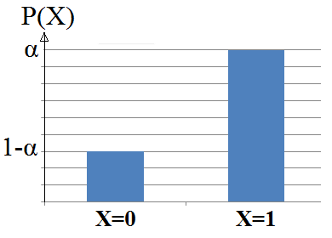

**Expected Value**

The expected value (population average) of a Bernoulli RV happens to be equal to α, the probability of success (Pass/Yes/Heads).

**Variance**

The variance of a Bernoulli RV can be computed as α(1-α), or the probability of success (Pass/Yes/Heads) multiplied by the probability of failure (Fail/No/Tails).

***Discrete – Poisson RV X***

**Idea**

Experiment where the outcome of interest is a count (e.g., # of trees in a region of a forest; # of cars passing a certain intersection in a minute; # of vacant houses in a block).

**Distribution Parameter**

λ, which happens to be both the expected value of X and variance of X (i.e., E(X) = V(X) = λ)

**Probability Mass Function (PMF)**

$$P\left(X\right)=\frac{λ^{x}e^{-λ}}{x!}$$

Here, x is a non-negative integer and λ > 0.

**Graph of PMF**

The shape of the PMF depends on value of λ

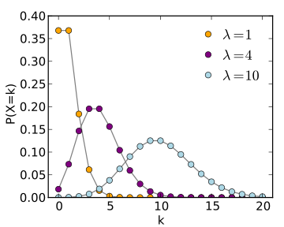

**Expected Value**

The expected value (population average) of a Poisson RV happens to be the parameter of the distribution, λ.

**Variance**

The variance of a Poisson RV happens to be equal to the parameter of the distribution, λ.

***Continuous – Normal RV X***

**Idea**

Many real world variables have a normal distribution (e.g., weight/height of people; median income/house value in Philly block groups; measurement error in stat. models).

**Distribution Parameters**

μ and σ2, which happen to be the expected value and variance of the RV, respectively

**Probability Density Function (PDF)**

$$P\left(X\right)=\frac{1}{\sqrt{2πσ^{2}}}e^{\frac{{-(x-μ)}^{2}}{2σ^{2}}}$$

Here, μ is any real number and σ > 0.

**Graph of PDF**

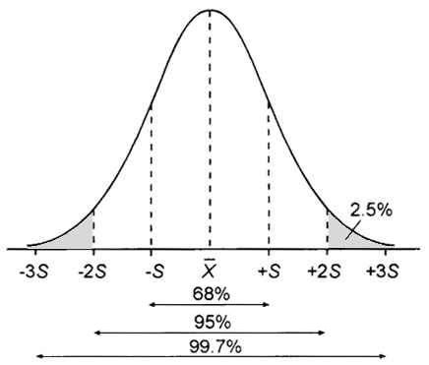

**Expected Value**

The expected value (population average) of a normal RV happens to be equal to one of the parameters of the normal distribution, μ.

**Variance**

The variance of a normal RV happens to be equal to one of the parameters of the normal distribution, σ2.

***Continuous – Standard Normal (SN) RV Z***

**Idea**

The standard normal distribution is a normal distribution where the mean μ = 0 and the variance σ2 = 1. Any normal RV X can be standardized and converted to a SN RV Z.

**Distribution Parameters**

By definition, μ=0 and σ2=1 (parameter values never vary, this is a special case of normal RV)

**Probability Density Function (PDF)**

$$P\left(Z\right)=\frac{1}{\sqrt{2π}}e^{\frac{{-x}^{2}}{2}}$$

*Interpretation:* We can interpret value z of rv Z as distance from the mean in terms of standard deviations. So z=2 means a value that’s 2 s.d.’s higher than the mean.

**Graph of PDF**

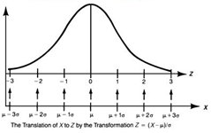

**Expected Value**

The expected value of a standard normal RV is always 0, by definition.

**Variance**

The variance of the standard normal RV is always 1, by definition.

***Discrete – Bernoulli RV X (cont’d)***

**Example**

Imagine we have an unfair coin, where the probability of getting heads is 0.53. Using this information, write/calculate:

1. The RV we’re dealing with, the parameter(s) and the value
2. The PMF
3. The expected value and variance of the RV

*Answers*:

1. Because we’re dealing with a coin toss and there are only two possible outcomes, this is a Bernoulli RV. The Bernoulli RV has only one parameter, α, and its value here is 0.53, the probability of heads (success).
2. If X=1 is the event where we get heads and X=0 is the event where we get tails, the PMF is
$$P\left(X\right)=\left\{\begin{matrix}α=0.53, if X=1 \\ 1-α=0.47, if X=0 \\ 0, otherwise\end{matrix}\right.$$

3. The expected value and variance of the RV are as follows:

E(X) = α = 0.53.

V(X) = α(1- α) = 0.53*0.47 = 0.2491.

***Discrete – Poisson RV X (cont’d)***

**Example**

Let X denote the number of vacant houses in an acre-sized region of a large densely populated urban area. Suppose that X has a Poisson distribution with λ = 1.6.

1. What is the probability that a randomly chosen one-acre region will contain exactly 8 vacant houses when λ = 1.6?
2. Interpret this probability.
3. What are the expected value and variance here?

*Answers:*

1. We can either plug in x=8 and λ = 1.6 into the PMF formula above, or write *=Poisson(8, 1.6, false)* in Excel or *dpois(8,1.6)* in R, and get 0.000215.
2. This means that if we repeat this experiment an infinite number of times (or look at infinitely many 1 acre regions), approximately 0.0215% of all 1 acre regions would have 8 vacant houses when λ = 1.6, over the multiple repetitions of the experiment.
3. The expected value and variance of the Poisson distribution are both λ, which in this example is 1.6. This means that if we look at infinitely many one-acre regions, on average they will contain 1.6 vacant houses, and the variance of the number of houses will also be 1.6.

***Continuous – Normal RV X (cont’d)***

**Example 1**

Recall that the CDF of a continuous RV is the probability that RV X is *at most* some value x. The CDF of the normal RV X at some value x is the area underneath the normal curve to the left of X=x, as shown below.

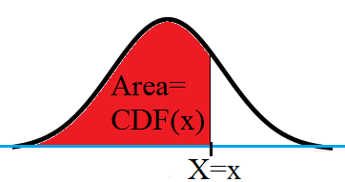

**Example 2**

Assume weight of 5 year olds is normally distributed with a mean of 50 lbs and s.d. of 10 lbs. Compute the following:

1. What is the probability that a randomly selected 5 year old will weigh exactly 48 lbs?
2. What is the probability that a randomly selected 5 year old will weigh between 45 and 55 lbs?

*Answers:*

1. Because we are dealing with a normal RV, which is continuous, we know that the probability of any single value is 0. So P(X=48)=0.
2. In order to answer this question, let’s look at the PDF of X. Basically, we want to find the value of the shaded area. This shaded area is CDF(X=55)-CDF(X=45).

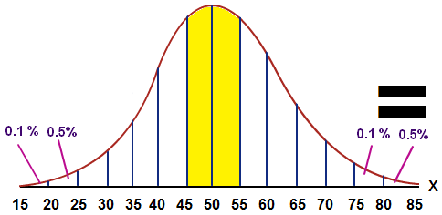

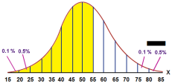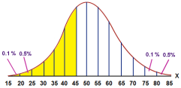

***Continuous – Normal/SN RV X (cont’d)***

**Example 2 (Cont’d from Normal RV)**

So let’s standardize X:

Calculate Z when X=55, μ=50, σ=10:

Z = (X-μ)/σ = (55-50)/10 = 0.5

Calculate Z when X=45, μ=50, σ=10:

Z = (X-μ)/σ = (45-50)/10 = -0.5.

So, the shaded area below, which is CDF(X=55)-CDF(X=45) is the same as CDF(Z=0.5)-CDF(Z=-0.5) = Φ(0.5) - Φ(-0.5).

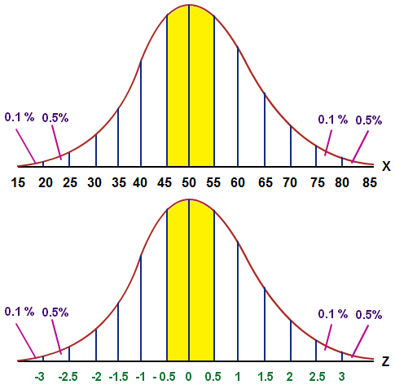

To calculate Φ(0.5), enter *=NORMSDIST(0.5)* into Excel. To calculate Φ(-0.5), enter *=NORMSDIST(-0.5)*. You get Φ(0.5) - Φ(-0.5) = 0.69-0.31 = 0.38. In R, you can do this by writing *pnorm(0.5)-pnorm(-0.5)*.

So the probability that X is between 45 and 55 lbs is the probability that it is within ±0.5 standard deviations of the mean of 50, and this probability is 0.38.